Evaluation summary

Code fragments identification evaluation
For evaluating the performance of our approach, we compare the report automatically obtained by our implementation with the ground truth. For each project, we compute the precision and the recall depending on the minimum score threshold set.
This chart represents the trends in the evolution of precision and recall as a function of score thresholds.
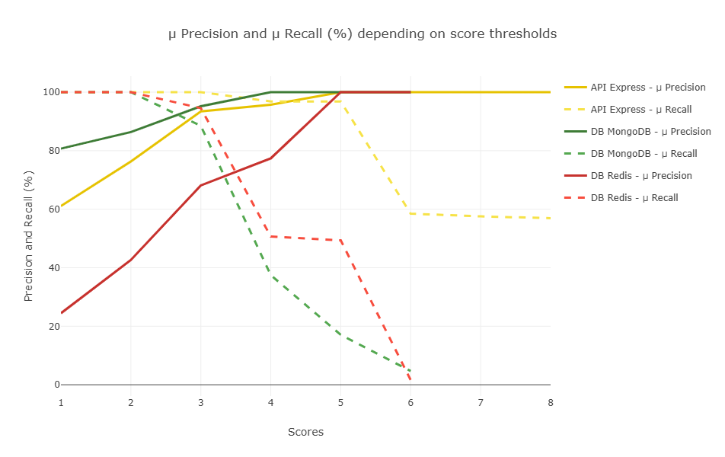
This chart represents raw data behind the previous chart.
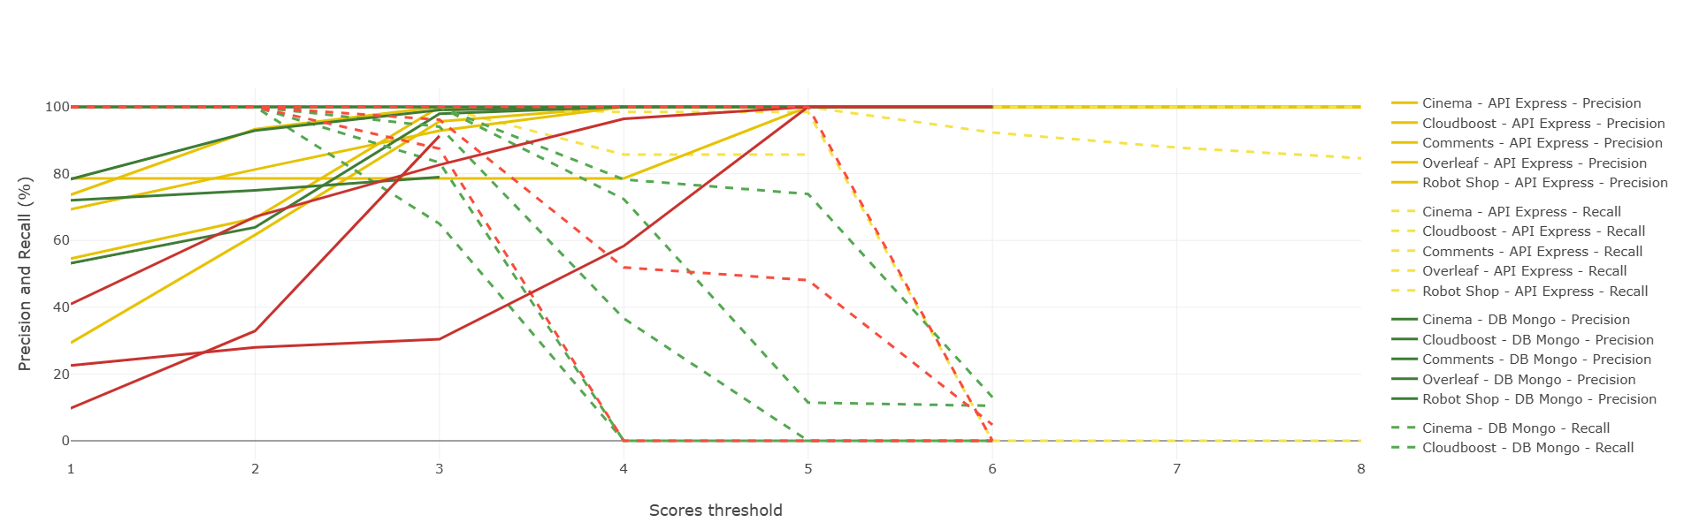

We can deduce, for each project, the optimal score threshold based on the best balance between precision and recall.
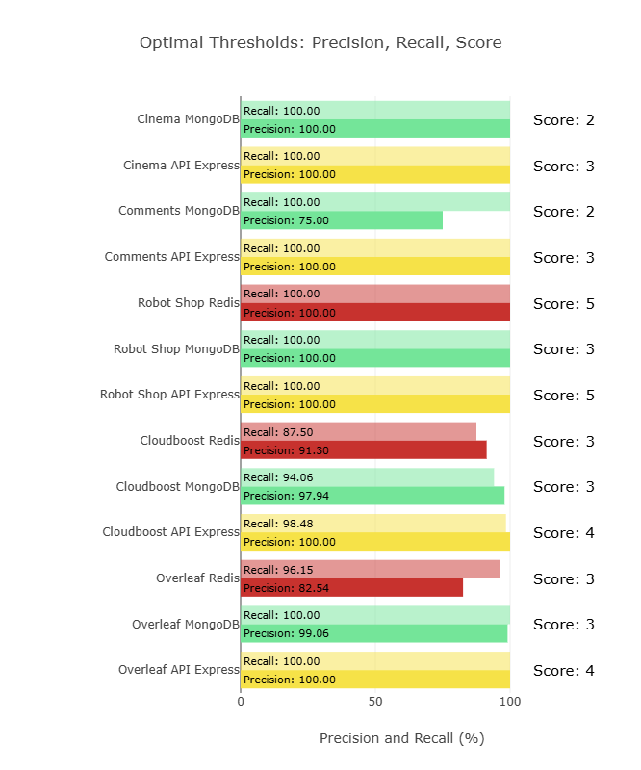
The charts above are created based on the following table.
API Express |  | Scores | 1 | 2 | 3 | 4 | 5 | 6 | 7 | 8
 | comments-api | Precision | 54,55% | 66,67% | 100,00% | 100,00% | 100,00% | 100,00% | 100,00% | 100,00%
 |  | Recall | 100,00% | 100,00% | 100,00% | 100,00% | 100,00% | 100,00% | 100,00% | 100,00%
 | cinema-microservice | Precision | 73,68% | 93,33% | 100,00% | 100,00% | 100,00% | N/A | N/A | N/A
 |  | Recall | 100,00% | 100,00% | 100,00% | 85,71% | 85,71% | 0,00% | 0,00% | 0,00%
 | overleaf | Precision | 69,33% | 81,25% | 92,86% | 100,00% | 100,00% | 100,00% | 100,00% | 100,00%
 |  | Recall | 100,00% | 100,00% | 100,00% | 100,00% | 100,00% | 92,31% | 87,82% | 84,62%
 | cloudboost | Precision | 29,33% | 61,68% | 95,65% | 100,00% | 100,00% | N/A | N/A | N/A
 |  | Recall | 100% | 100,00% | 100,00% | 98,48% | 98,48% | 0% | 0% | 0%
 | robot-shop | Precision | 78,57% | 78,57% | 78,57% | 78,57% | 100,00% | 100,00% | 100,00% | 100,00%
 |  | Recall | 100,00% | 100,00% | 100,00% | 100,00% | 100,00% | 100,00% | 100,00% | 100,00%
 |  | Precision average ($μ)$ | 61,09% | 76,30% | 93,42% | 95,71% | 100,00% | 100,00% | 100,00% | 100,00%
 |  | Recall average ($μ)$ | 100,00% | 100,00% | 100,00% | 96,84% | 96,84% | 58,46% | 57,56% | 56,92%

DB Mongo |  | Scores | 1 | 2 | 3 | 4 | 5 | 6
 | comments-api | Precision | 72,00% | 75,00% | 78,95% | N/A | N/A | N/A
 |  | Recall | 100,00% | 100,00% | 83,33% | 0,00% | 0,00% | 0,00%
 | cinema-microservice | Precision | 100,00% | 100,00% | 100,00% | N/A | N/A | N/A
 |  | Recall | 100,00% | 100,00% | 65,00% | 0,00% | 0,00% | 0,00%
 | overleaf | Precision | 78,36% | 92,92% | 99,06% | 100,00% | 100,00% | 100,00%
 |  | Recall | 100,00% | 100,00% | 100,00% | 72,38% | 11,43% | 10,48%
 | cloudboost | Precision | 53,16% | 63,92% | 97,94% | 100,00% | N/A | N/A
 |  | Recall | 100% | 100,00% | 94,06% | 36,63% | 0% | 0%
 | robot-shop | Precision | 100,00% | 100,00% | 100,00% | 100,00% | 100,00% | 100,00%
 |  | Recall | 100,00% | 100,00% | 100,00% | 78,26% | 73,91% | 13,04%
 |  | Precision average ($μ)$ | 80,70% | 86,37% | 95,19% | 100,00% | 100,00% | 100,00%
 |  | Recall average ($μ)$ | 100,00% | 100,00% | 88,48% | 37,46% | 17,07% | 4,70%

DB Redis |  | Scores | 1 | 2 | 3 | 4 | 5 | 6
 | overleaf | Precision | 40,94% | 67,10% | 82,64% | 96,43% | 100,00% | 100,00%
 |  | Recall | 100,00% | 100,00% | 96,15% | 51,92% | 48,08% | 4,81%
 | cloudboost | Precision | 9,76% | 32,88% | 91,30% | N/A | N/A | N/A
 |  | Recall | 100% | 100,00% | 87,50% | 0% | 0% | 0%
 | robot-shop | Precision | 22,58% | 28,00% | 30,43% | 58,33% | 100,00% | N/A
 |  | Recall | 100,00% | 100,00% | 100,00% | 100,00% | 100,00% | 0,00%
 |  | Precision average ($μ)$ | 24,43% | 42,66% | 68,13% | 77,38% | 100,00% | 100,00%
 |  | Recall average ($μ)$ | 100,00% | 100,00% | 94,55% | 50,64% | 49,36% | 1,60%

Heuristics evaluation
For evaluating the individual relevance of our code fragment identification heuristics, we compute separately their precision and recall for each project codebase, based on the ground truth. We remove heuristics that make no contribution to the score.
